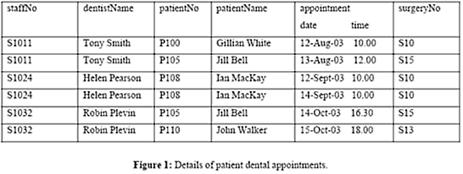

Can’t insert a staff without an appointment because appointment is the primary key so its an insertion anomaly.

Deletion anomaly is if you delete a field and it affects another one. If you delete dentist name Robin Plevin, John walkers file would cease to exist (Jill Bell was associated with Tony Smith so its okay)

Update anomaly would happen if you try to update the dentist name

`modification anomaly is if you change the name to say Robin Car, you have to update all of them otherwise it wouldn’t exist and cause an error